Number Types
# Source: AI Source: Provided by: [Data Path: Persons Table -> ID Column: 1, Name_En Column: Motasem Essam] -> From: [ChatGPT] on [7/11/2026]
Number Types are classifications of numbers based on their mathematical properties and the sets to which they belong. Each number type groups numbers that share common characteristics, allowing mathematicians to study, compare, and apply them systematically.
Number types form the foundation of arithmetic, algebra, geometry, trigonometry, calculus, statistics, computer science, engineering, economics, and nearly every branch of mathematics.

Definition
# Source: AI Source: Provided by: [Data Path: Persons Table -> ID Column: 1, Name_En Column: Motasem Essam] -> From: [ChatGPT] on [7/11/2026]
A Number Type is a category of numbers defined by a specific set of mathematical properties.
Each successive number system generally extends the previous one to solve new mathematical problems.

Hierarchy of Number Types
# Source: AI Source: Provided by: [Data Path: Persons Table -> ID Column: 1, Name_En Column: Motasem Essam] -> From: [ChatGPT] on [7/11/2026]
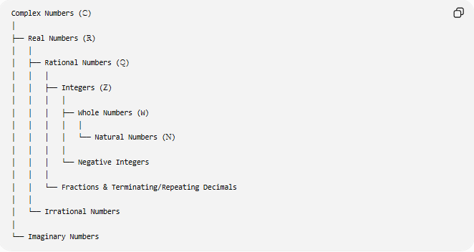
Complex Numbers (ℂ)
│
├── Real Numbers (ℝ)
│ │
│ ├── Rational Numbers (ℚ)
│ │ │
│ │ ├── Integers (ℤ)
│ │ │ │
│ │ │ ├── Whole Numbers (W)
│ │ │ │ │
│ │ │ │ └── Natural Numbers (ℕ)
│ │ │ │
│ │ │ └── Negative Integers
│ │ │
│ │ └── Fractions & Terminating/Repeating Decimals
│ │
│ └── Irrational Numbers
│
└── Imaginary Numbers

Main Number Types
# Source: AI Source: Provided by: [Data Path: Persons Table -> ID Column: 1, Name_En Column: Motasem Essam] -> From: [ChatGPT] on [7/11/2026]
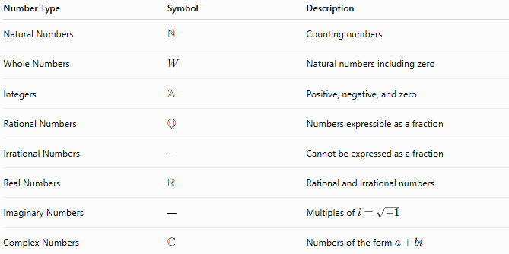
Number Type | Symbol | Description
Natural Numbers | $$N$$ | Counting numbers
Whole Numbers | $$W$$ | Natural numbers including zero
Integers | $$Z$$ | Positive, negative, and zero
Rational Numbers | $$Q$$ | Numbers expressible as a fraction
Irrational Numbers | — | Cannot be expressed as a fraction
Real Numbers | $$R$$ | Rational and irrational numbers
Imaginary Numbers | — | Multiples of $i=\sqrt{-1}$
Complex Numbers | $$C$$ | Numbers of the form $a+bi$

1. Natural Numbers
# Source: AI Source: Provided by: [Data Path: Persons Table -> ID Column: 1, Name_En Column: Motasem Essam] -> From: [ChatGPT] on [7/11/2026]
Symbol:
$$N$$
Examples:
$$1,2,3,4,5,…$$
Used for:
- Counting
- Ordering
- Basic arithmetic

2. Whole Numbers
# Source: AI Source: Provided by: [Data Path: Persons Table -> ID Column: 1, Name_En Column: Motasem Essam] -> From: [ChatGPT] on [7/11/2026]
Examples:
$$0,1,2,3,4,…$$
Properties:
- Include zero
- No negative numbers

3. Integers
# Source: AI Source: Provided by: [Data Path: Persons Table -> ID Column: 1, Name_En Column: Motasem Essam] -> From: [ChatGPT] on [7/11/2026]
Symbol:
$$Z$$
Examples:
$$…,-3,-2,-1,0,1,2,3,…$$
Properties:
- Positive
- Negative
- Zero

4. Rational Numbers
# Source: AI Source: Provided by: [Data Path: Persons Table -> ID Column: 1, Name_En Column: Motasem Essam] -> From: [ChatGPT] on [7/11/2026]
Symbol:
$$Q$$
Definition:
Can be written as
$$\frac{a}{b},b≠0$$
Examples:
$$\frac{1}{2},-\frac{3}{4},5,0.25,0.333…$$
Properties:
- Fractions
- Terminating decimals
- Repeating decimals

5. Irrational Numbers
# Source: AI Source: Provided by: [Data Path: Persons Table -> ID Column: 1, Name_En Column: Motasem Essam] -> From: [ChatGPT] on [7/11/2026]
Definition:
Cannot be expressed as a fraction of two integers.
Examples:
$$π,e,\sqrt{2},\sqrt{3},ϕ$$
Properties:
- Infinite decimal expansion
- Non-repeating
- Non-terminating

6. Real Numbers
# Source: AI Source: Provided by: [Data Path: Persons Table -> ID Column: 1, Name_En Column: Motasem Essam] -> From: [ChatGPT] on [7/11/2026]
Symbol:
$$R$$
Definition:
All rational and irrational numbers.
Examples:
$$-5, 0, \frac{2}{3}, π, \sqrt{2}$$

7. Imaginary Numbers
# Source: AI Source: Provided by: [Data Path: Persons Table -> ID Column: 1, Name_En Column: Motasem Essam] -> From: [ChatGPT] on [7/11/2026]
Definition:
Numbers involving
$$i=\sqrt{-1}$$
Examples:
$$i, 2i, -5i$$

8. Complex Numbers
# Source: AI Source: Provided by: [Data Path: Persons Table -> ID Column: 1, Name_En Column: Motasem Essam] -> From: [ChatGPT] on [7/11/2026]
Symbol:
$$C$$
Definition:
Numbers of the form
$$a+bi$$
where
- $a$is the real part
- $b$is the imaginary part
Examples:
$$3+2i, -4+i, 7-5i$$

Relationships Between Number Types
# Source: AI Source: Provided by: [Data Path: Persons Table -> ID Column: 1, Name_En Column: Motasem Essam] -> From: [ChatGPT] on [7/11/2026]
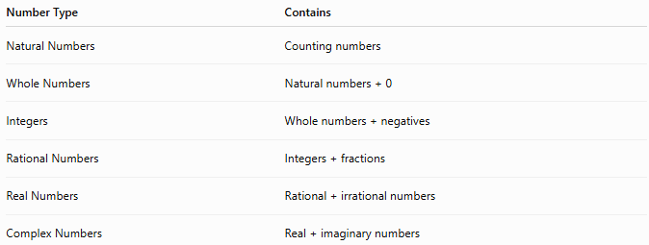
Number Type | Contains
Natural Numbers | Counting numbers
Whole Numbers | Natural numbers + 0
Integers | Whole numbers + negatives
Rational Numbers | Integers + fractions
Real Numbers | Rational + irrational numbers
Complex Numbers | Real + imaginary numbers

Examples of Classification
# Source: AI Source: Provided by: [Data Path: Persons Table -> ID Column: 1, Name_En Column: Motasem Essam] -> From: [ChatGPT] on [7/11/2026]
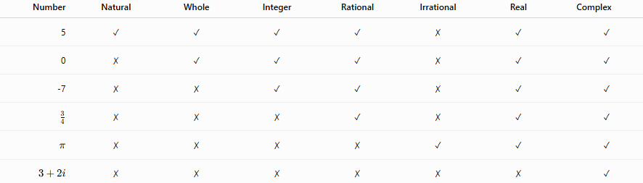
Number | Natural | Whole | Integer | Rational | Irrational | Real | Complex
5 | ✓ | ✓ | ✓ | ✓ | ✗ | ✓ | ✓
0 | ✗ | ✓ | ✓ | ✓ | ✗ | ✓ | ✓
-7 | ✗ | ✗ | ✓ | ✓ | ✗ | ✓ | ✓
$$\frac{3}{4}$$ | ✗ | ✗ | ✗ | ✓ | ✗ | ✓ | ✓
$$π$$ | ✗ | ✗ | ✗ | ✗ | ✓ | ✓ | ✓
$$3+2i$$ | ✗ | ✗ | ✗ | ✗ | ✗ | ✗ | ✓

Applications
# Source: AI Source: Provided by: [Data Path: Persons Table -> ID Column: 1, Name_En Column: Motasem Essam] -> From: [ChatGPT] on [7/11/2026]
Number types are used in:
- Arithmetic
- Algebra
- Geometry
- Trigonometry
- Calculus
- Statistics
- Engineering
- Computer Science
- Physics
- Economics

Real-Life Applications
# Source: AI Source: Provided by: [Data Path: Persons Table -> ID Column: 1, Name_En Column: Motasem Essam] -> From: [ChatGPT] on [7/11/2026]
Number types are used in:
- Financial calculations
- Engineering measurements
- Computer programming
- Cryptography
- Scientific simulations
- Data analysis
- Electrical engineering
- Physics
- Architecture
- Artificial intelligence

Common Mistakes
# Source: AI Source: Provided by: [Data Path: Persons Table -> ID Column: 1, Name_En Column: Motasem Essam] -> From: [ChatGPT] on [7/11/2026]
- Confusing whole numbers with integers.
- Thinking every decimal is irrational.
- Believing every rational number is an integer.
- Confusing imaginary numbers with complex numbers.
- Assuming irrational numbers are not real numbers.

Key Points
# Source: AI Source: Provided by: [Data Path: Persons Table -> ID Column: 1, Name_En Column: Motasem Essam] -> From: [ChatGPT] on [7/11/2026]
- Every natural number is a whole number.
- Every whole number is an integer.
- Every integer is a rational number.
- Every rational and irrational number is a real number.
- Every real number is also a complex number (with imaginary part equal to zero).

Number Types vs. Special Numbers
# Source: AI Source: Provided by: [Data Path: Persons Table -> ID Column: 1, Name_En Column: Motasem Essam] -> From: [ChatGPT] on [7/11/2026]
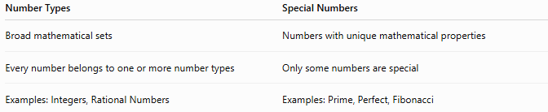
Number Types | Special Numbers
Broad mathematical sets | Numbers with unique mathematical properties
Every number belongs to one or more number types | Only some numbers are special
Examples: Integers, Rational Numbers | Examples: Prime, Perfect, Fibonacci

Number Types vs. Mathematical Constants
# Source: AI Source: Provided by: [Data Path: Persons Table -> ID Column: 1, Name_En Column: Motasem Essam] -> From: [ChatGPT] on [7/11/2026]
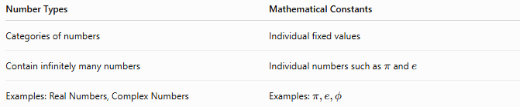
Number Types | Mathematical Constants
Categories of numbers | Individual fixed values
Contain infinitely many numbers | Individual numbers such as $π$and $e$
Examples: Real Numbers, Complex Numbers | Examples: $π,e,ϕ$

Number Types vs. Number Systems
# Source: AI Source: Provided by: [Data Path: Persons Table -> ID Column: 1, Name_En Column: Motasem Essam] -> From: [ChatGPT] on [7/11/2026]
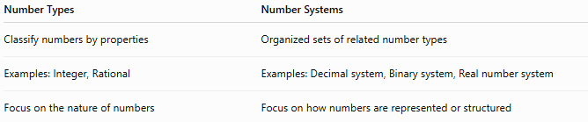
Number Types | Number Systems
Classify numbers by properties | Organized sets of related number types
Examples: Integer, Rational | Examples: Decimal system, Binary system, Real number system
Focus on the nature of numbers | Focus on how numbers are represented or structured

Conclusion
# Source: AI Source: Provided by: [Data Path: Persons Table -> ID Column: 1, Name_En Column: Motasem Essam] -> From: [ChatGPT] on [7/11/2026]
Number Types classify numbers according to their mathematical properties and relationships. The principal categories—natural numbers, whole numbers, integers, rational numbers, irrational numbers, real numbers, imaginary numbers, and complex numbers—form a hierarchical structure in which each larger set extends the previous one. Understanding these number types provides the foundation for nearly every area of mathematics and its applications in science, engineering, economics, and computer science.

